LAB NO 1
Introduction to Eclipse IDE
LAB TASK:
1: 1.Write the java code with the help of the given class diagram of Hospital Management System.

CODE:
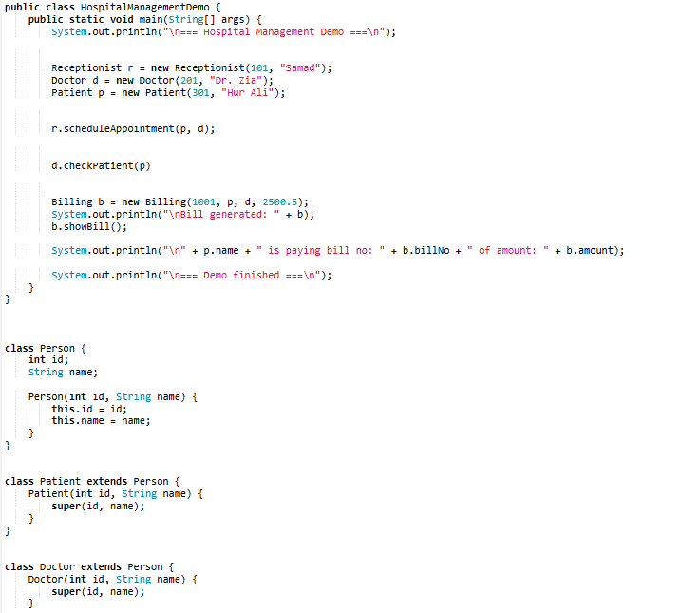

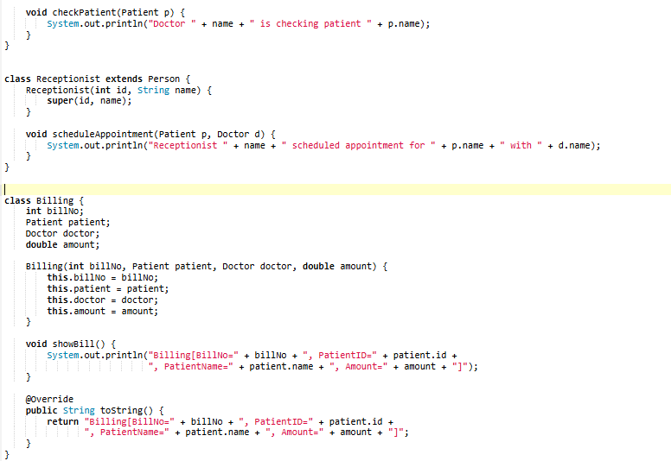

OUTPUT:
